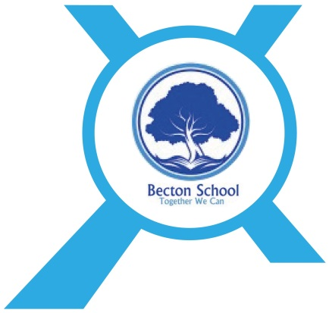

RSC/PSHE/Citizenship Policy

Date Published | September 2022
Version | 1
Approved Date | October 2022
Review Cycle | Annual
Review Date | October 2023

An academy within:

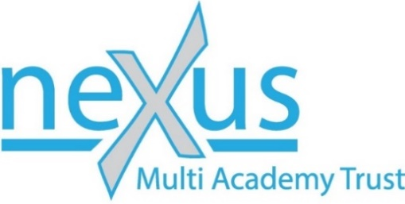

“Learning together, to be the best we can be”

- Introduction
The teaching of PSHE and Citizenship at Becton School is central to the development of all our pupils. It enables the students to become healthy, independent and responsible members of our school community and the wider society.

The main aims of our curriculum are to enable the students:

- To improve resilience so that they can cope with the difficult and diverse changes that come their way
- To stay as healthy as possible
- To learn to keep themselves and others safe, including recognising signs of bullying and knowing where to turn to for help
- To learn how to use the internet, including social media, safely and responsibly
- To develop effective, satisfying and safe relationships
- To learn to recognise similarities and differences between themselves and others and to respect these differences in order to be independent and responsible members of the school and wider community
- To be positive and active members of a democratic society
- To develop self-confidence and self-esteem, and to make informed choices regarding personal and social issues
- To develop good relationships with other members of the school and wider community

PSHE values and skills are taught using a 'spiral curriculum' structured around core themes which are revisited throughout the student’s school life. The PSHE curriculum also encompasses Resilience, Citizenship and Life Skills lessons across the school. An emphasis is placed on active learning through planned discussions, investigations and problem-solving. Teachers endeavour to provide a safe learning environment through the establishment of clear ground rules with the group which are made explicit to the student and reinforced consistently. This allows pupils to discuss feelings and sensitive issues within a non- threatening and supportive environment. Visiting speakers also contribute to the taught curriculum where appropriate.

Beyond timetabled PSHE lessons, pupils are supported in applying the skills they are learning, in real-life situations as they arise: e.g. resolving conflicts, feelings, working as part of a group on a project. The PSHE curriculum is based on a rolling programme. Each year, pupils are given the opportunity to learn about and develop skills in three core areas:

- Relationships
- Health and Wellbeing
- Living in a Wider World

Our PSHE Curriculum already takes the changes to the RSE statutory requirements into account.

Sex and Relationships education is learning about the emotional, social and physical aspects of growing up, relationships, sex, human sexuality and sexual health, diversity and personal identity.

For Primary Aged Pupils The Focus Is On Relationship Education, Including:

- friends and family
- bullying (including e-safety)
- emotions
- health and hygiene
- stranger danger
- Puberty will be addressed with individual pupils as and when it is appropriate

For Secondary Aged Pupils There Is Further Development In These Areas, Whilst Pupils Will Also Learn About:

- puberty
- intimate relationships,
- how to recognize, understand and build healthy relationships and how to recognize unhealthy relationships
- self-respect and respect for others,
- consent, and how to manage conflict
- how relationships may affect health and wellbeing, including mental health
- online safety
- sexual health, contraception, sexuality
- harmful sexual behaviour includes sexual harassment, online sexual abuse, sexual violence and sexualised language.

Skills and knowledge in all areas of the curriculum build upon pupils' prior learning and experiences and lessons are differentiated according to physical, emotional and cognitive development of individual pupils. An overview of the topics to be covered can be seen below.

Teaching and Learning Strategies

At Becton School, PSHE is taught through a team approach which includes teachers, HLTAs, teaching assistants and Health Authority staff within school (Becton School centre). Long term plans have been written for all PHSE/RSE staff to access which are then adapted by class staff to suit individual pupil needs. PSHE and Citizenship is a spiral curriculum for one lesson per week across the whole school.
In addition to the discreet lessons, knowledge and understanding is reinforced using a range of opportunities as appropriate which include:

- Whole school/class sessions
- Small group sessions
- 1:1 session
- Discussion
- Creative activities
- Visiting speakers
- Out of school visits

Post -16 Programme Of Study
All Post 16 students are building on the work pupils have completed in Primary and Secondary. Most will be repeating Y11 due to missing in education.
- Developing self
- Dealing with problems in daily life
- Environmental awareness
- Healthy living
- Individual rights and responsibilities
- Making the most of leisure time
- Managing own money
- Managing social relationships
- Parenting awareness
- Preparation for work
- Working as part of a group
- Working towards goals
- Community action
- Using technology in the home and community
- Personal safety in the home and community

Those delivering the lesson will choose the method most appropriate for their class to meet the objectives of the lesson and most importantly the needs of the pupils.

Resources

Staff follow a spiral curriculum programme based on guidance provided by the PSHE Association Programme of Study. Resources are planned to support each Medium Term Plan. Resources are kept in the X Drive PSHE area of the school resource section.

- Equal Opportunities

All students have equal access to the curriculum and developmentally appropriate materials and resources. Delivery will be differentiated appropriately according to need. Resources are sensitive to the needs and backgrounds of the student and are monitored regularly to ensure their appropriateness.

Parental And Community Involvement

Working with parents is a vital part of the school approach to PSHE. Parents are invited to join in events in school, such as drop in sessions organised by parents group. They are kept informed of what is being taught in PSHE through curriculum information on the website and are consulted over some of the more sensitive areas of the curriculum.

There are links with local businesses and councillors as part of the work in Citizenship. Links have been made with local churches and community groups.

Outside agencies such as School Health Advisors, the Police liaison officer and dental health advisors may be invited to support the delivery of some aspects of the curriculum.
Assessment, Recording and Reporting

Pupils’ understanding, knowledge and skills are assessed through observation, discussion, questioning and participation in groups.

Parents are informed of pupil progress through annual reviews, the EHCP and Medical review process.

Continued Professional Development.

All staff are encouraged to attend local and national courses as appropriate.

