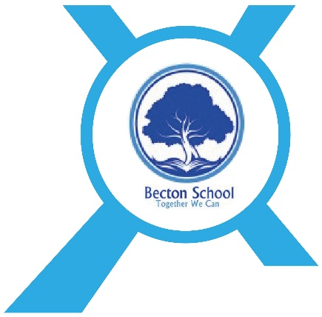

Careers Policy

Date Published | February 2022
Version | 1
Approved Date | March 2022
Review Cycle | 1 Year
Review Date | March 2023

An academy within:
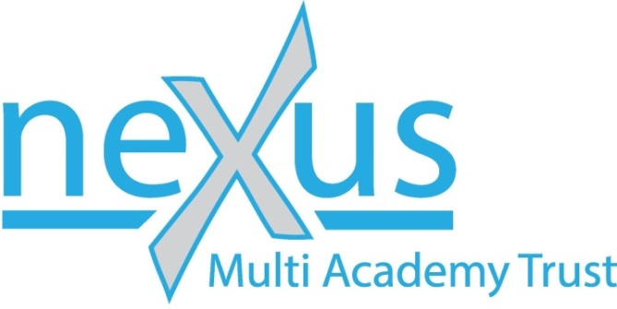

“Learning together; to be the best we can be”
- Introduction

- Our policy on Careers and Enterprise Education is based on the requirements of providing young people with a careers education which equips them with employability skills and offers independent careers advice in order for them to have the best possible chance of being in employment in the future
- Careers and Enterprise Education is National Curriculum requirement and is taught through specific Enterprise lessons, Careers Fairs and as part of Personal, Social and Health Education at Becton School.

- Aims
Careers and Enterprise Education teaches our students:
- To become resilient and independent learners
- To have high aspirations
- To have an idea of their plans for the future
- To improve their employability skills
- An awareness of the world of work and what careers are available

Roles & Responsibilities
- Allie Simpson – Career and Enterprise lead
- Sue Bradshaw (Sheffield Futures) – Careers Professional

Organisation & Content

Through our Careers and Enterprise Programme ‘Stepping Stones’ we will provide children with the necessary skills and experiences required for them to confidently enter the world of work when they have completed their education.
…consists of a variety of different Careers and Enterprise experiences that will equip children with work related skills. These include:
- Enterprise activities; including Young Enterprise, team challenges, fun days and other events throughout the year
- Enterprise skills embedded throughout the curriculum
- Careers learning embedded throughout the curriculum
- Careers learning as a unit of PSHE
- Experience of jobs and workplaces – children will visit different places of work and will discuss and review what they have learnt
- Independent careers advice for all children in years 9, 10 and 11
- Work experience for children in Upper School

Contact / information

Parents and carers will receive information and updates about ways to support children on their journey into the world of work and further education through EHCP reviews and over the course of the year as opportunities become available.
If you would like any more information about our Careers Programme or for further help and support please contact:
Allie Simpson (Careers Lead): asimpson@nexusmat.org
Sue Bradshaw (Careers Professional): sue.bradshaw@sheffield.gov.uk

