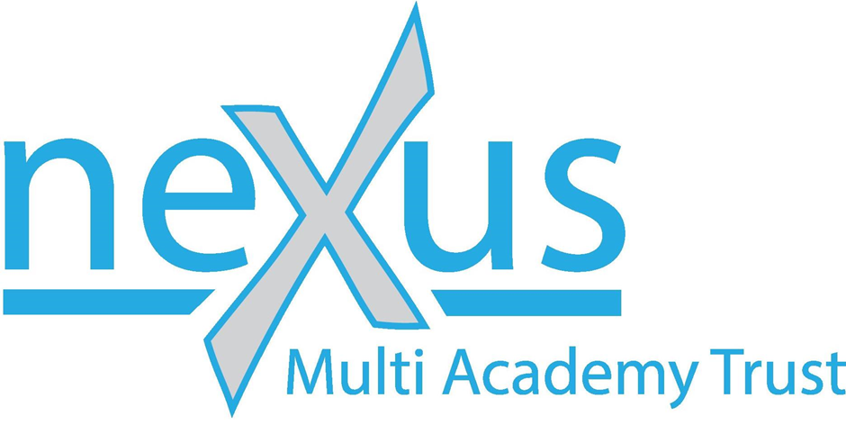

Privacy Notice

Our contact details
Name: Nexus Multi Academy Trust
Address: 300 Meadowhall Way, South Yorkshire, S9 1EA
Phone Number: 01709 257277
E-mail: foi@nexusmat.org

The type of personal information we collect
We currently collect and process the following information:
- Absence and Exclusion Data
- Educational History
- Free School Meals Eligibility
- Pupil Personal identifiers, contacts and characteristics (for example, name and contact details)
- Register of Business and Pecuniary Interests
- Special Educational Needs
- Staff Personal identifiers, contacts and characteristics (for example, name and contact details)

How we get the personal information and why we have it
Most of the personal information we process is provided to us directly by you for one of the following reasons:
- You are a pupil
- You are a parent/carer registering your child at our Trust
- You are a visitor attending our Trust
- You are a volunteer or hold a governance role
- You have applied for a job or secondment with us
- You have made an information request, complaint or enquiry to us
- You are a visitor to our website
The collection of personal data is essential for the Trust’s operational use. Whilst the majority of the information provided to us is mandatory, some of it is requested on a voluntary basis.

We may also receive personal information about you indirectly, for example:
- If you are a pupil, your previous school will send us your education file when you join our Trust
- A parent/carer may give us your name and contact details in case we cannot contact them directly, or to make us aware that you are authorised to collect their child from school
- An employee may give us your name and contact details as their ‘emergency contact’ or next of kin
- Your name and contact details may be given to us by job applicants, volunteers or governors, as a referee to support their application
- Public authorities, regulators or law enforcement bodies may give us information to assist them in their enquiries or to help safeguard children.

How we store your personal information
Your information is securely stored.

Your data protection rights
Under data protection law, you have rights including:
Your right of access - You have the right to ask us for copies of your personal information.
Your right to rectification - You have the right to ask us to rectify personal information you think is inaccurate. You also have the right to ask us to complete information you think is incomplete.
Your right to erasure - You have the right to ask us to erase your personal information in certain circumstances.
Your right to restriction of processing - You have the right to ask us to restrict the processing of your personal information in certain circumstances.
Your right to object to processing - You have the the right to object to the processing of your personal information in certain circumstances.
Your right to data portability - You have the right to ask that we transfer the personal information you gave us to another organisation, or to you, in certain circumstances.
You are not required to pay any charge for exercising your rights. If you make a request, we have one month to respond to you.
Please contact us at foi@nexusmat.org if you wish to make a request.

How to complain
If you have any concerns about our use of your personal information, you can make a complaint to us at complaints@nexusmat.org
You can also complain to the ICO if you are unhappy with how we have used your data.
The ICO’s address:
Information Commissioner’s Office
Wycliffe House
Water Lane
Wilmslow
Cheshire
SK9 5AF

Helpline number: 0303 123 1113
ICO website: https://www.ico.org.uk

